**Network load balancer:**

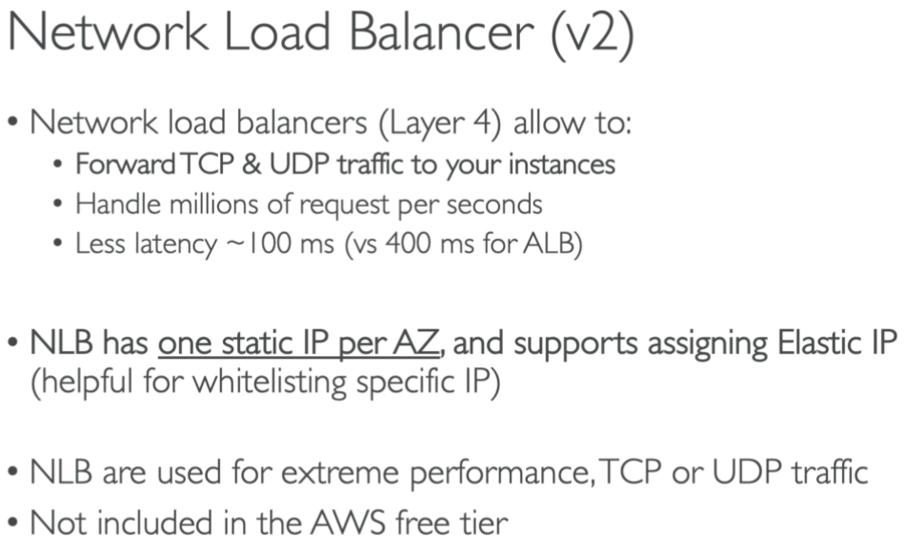

* NLBs are used when we need extreme performance or when we want to do load balancing on TCP or UDP.

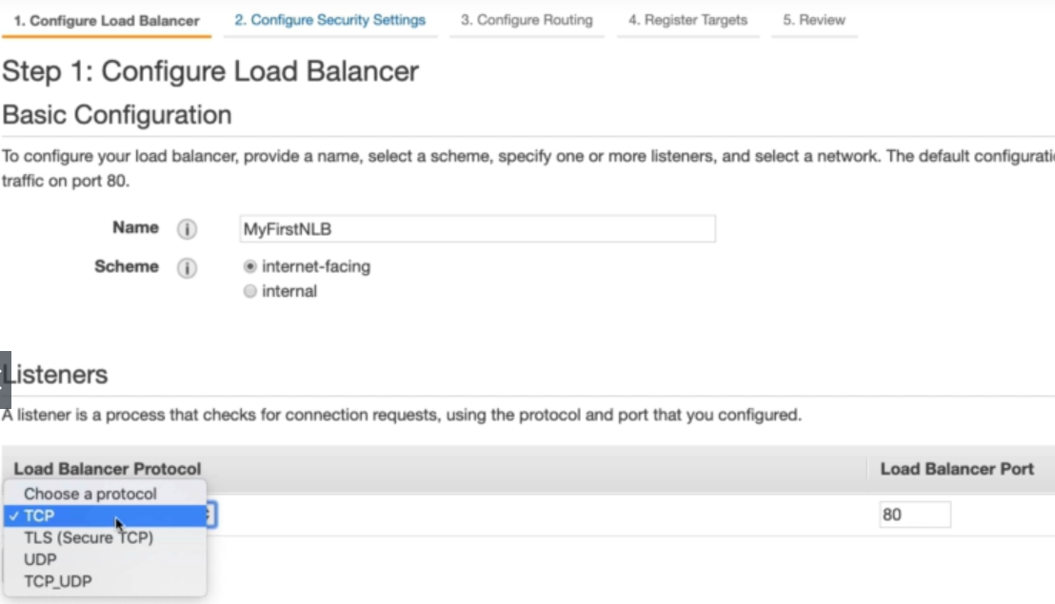

* While creating NLB, give it a name and select internet facing or internal option as above.
* We don’t have HTTP or HTTPS here. We an select TCP, TLS or UDP here
* TLS is secured TCP.

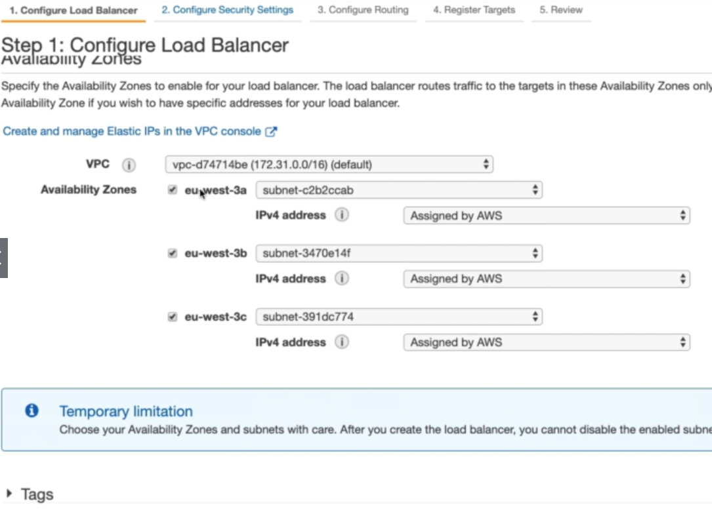

* Select VPC & availability zones and tags if we want.

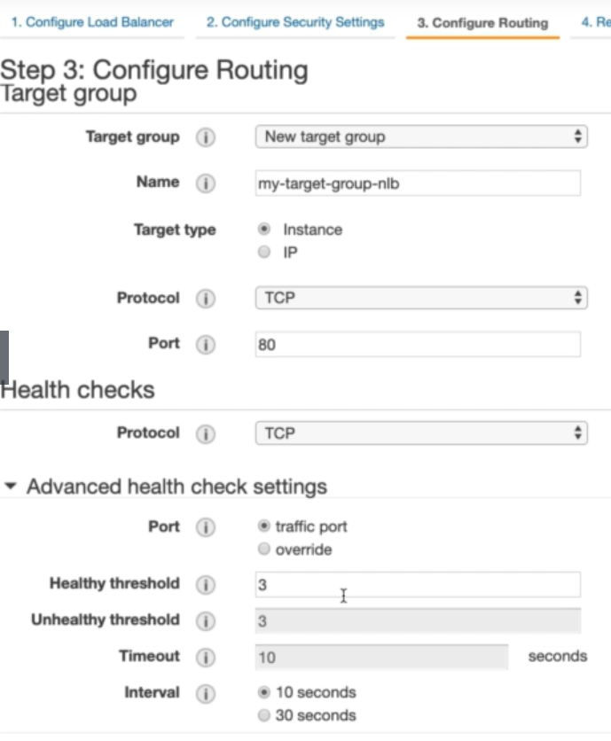

* and configure setting same as ALB.

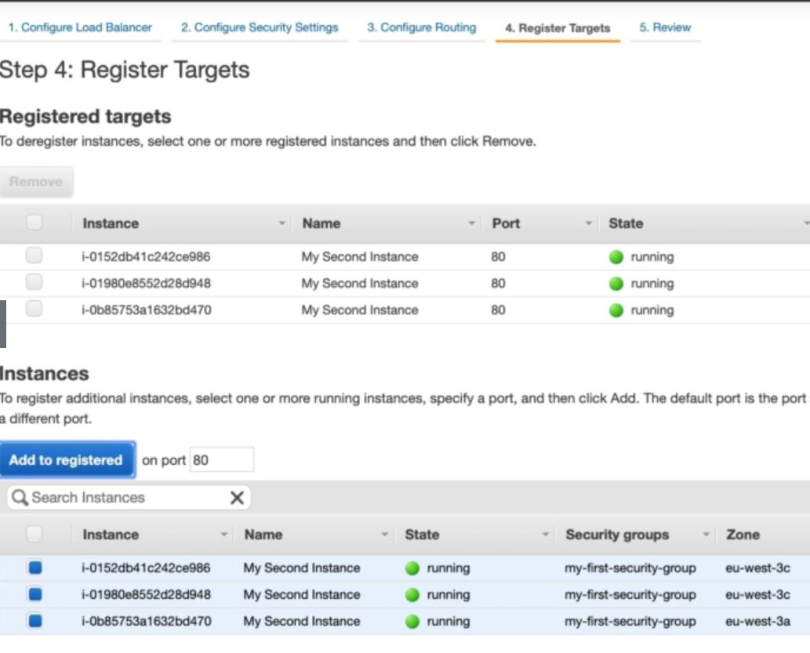

* Add instances, review and create the load balancer.
* We don’t set up any security groups in NLB as we do in other load balancers

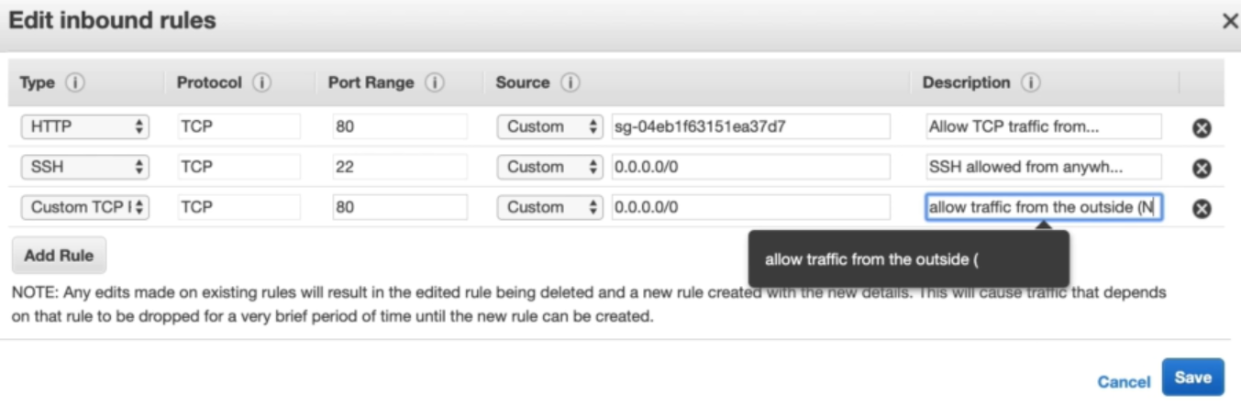

* So, we need to add the above rules in security group of the instances.
* Because the through the NLB, the traffic comes like from outside.

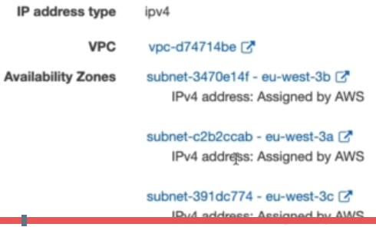

* Static IPv4 address be assigned to the NLB when we select the availability zones while creating the load balancer.